Design Specification

Task Assignment System

Develop By:

Mr.Kitti Wugprakhon [IN]  
  
087 247 4891

[anonwug@hotmail.com](mailto:anonwug@hotmail.com)

Table of Contents

1. Environment Setup 3

2. Project Setup 5

3. Project Structure Description 10

4. Library Jar 12

5. API RESTFul Description 12

4. User Interface Description 16

# 

# 1. Environment Setup

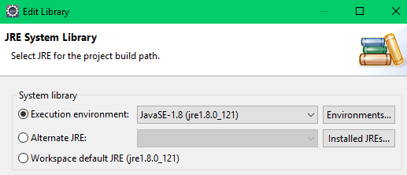 1.1 Java Development Kit (JDK)

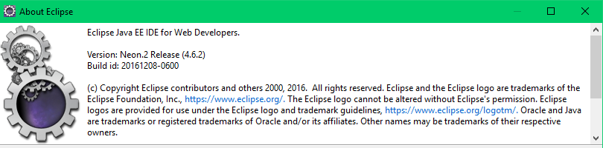 1.2 Eclipse IDE

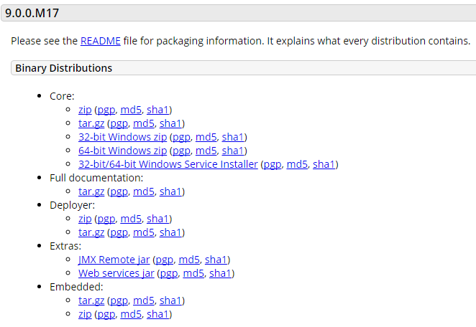 1.3 Apache Tomcat  
 You can download from http://tomcat.apache.org/download-90.cgi

Config Apache Tomcat Server in Eclipse.

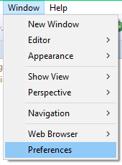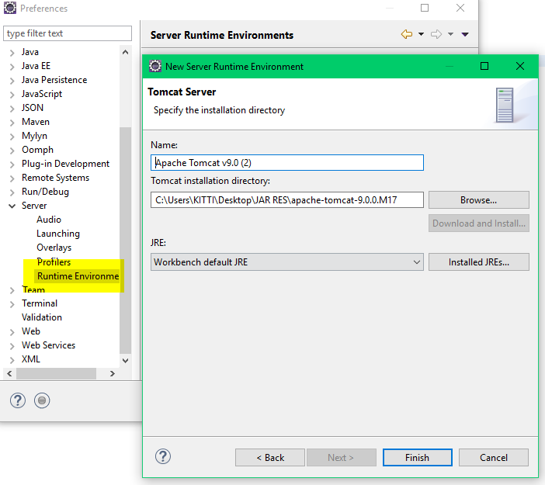

1.4 Git Repository  
 https://github.com/kittiwug/TaskAssignmentProject.git

# 2. Project Setup

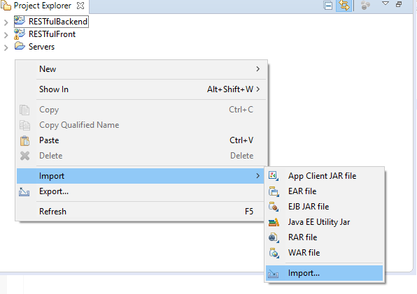 Import Project.

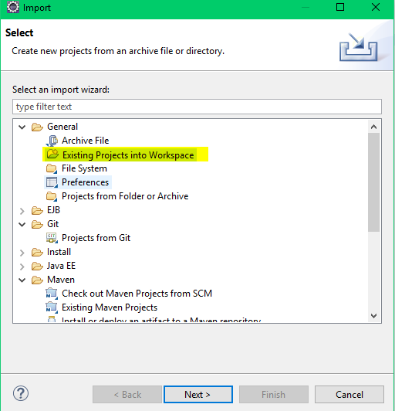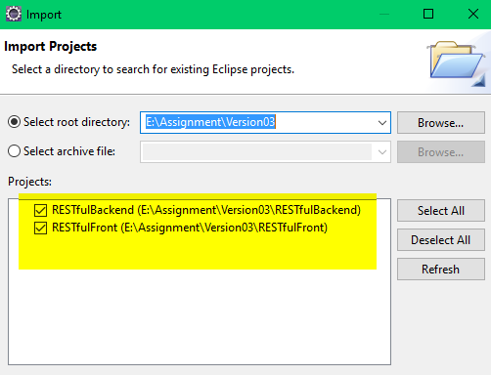 Choose : General > Existing Project into Workspace

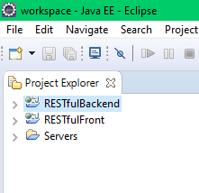

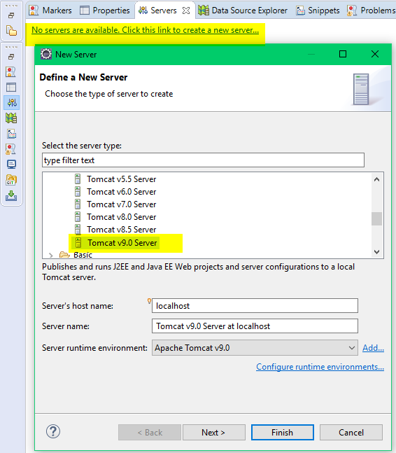 Create new Server.

Add project to Tomcat Server.

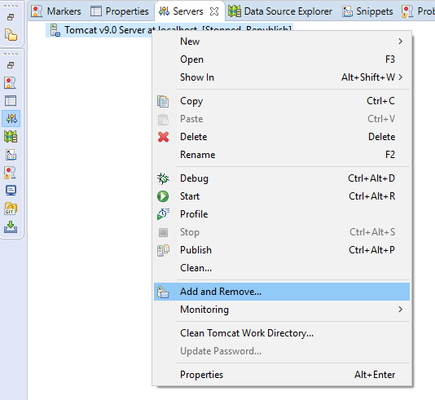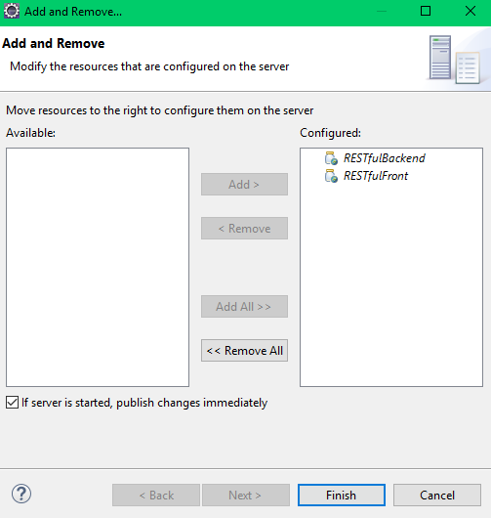

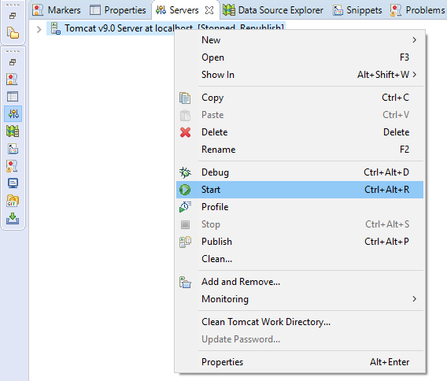 Start Server

# 3. Project Structure Description

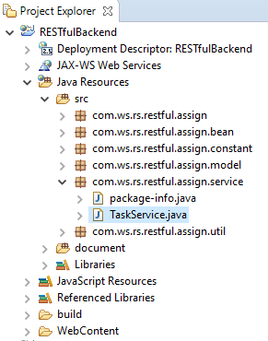 3.1 RESTfulBackend  
 Develop by JAVA.

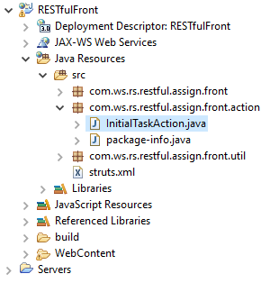 3.2 RESTfulFront  
 Develop by JAVA , Strut2 framework, AngularJS framework. There is **TaskService.java** for control servlet request from client.

# 4. Library Jar

Both project collect library jar file in folder "WebContent/WEB-INF/lib".

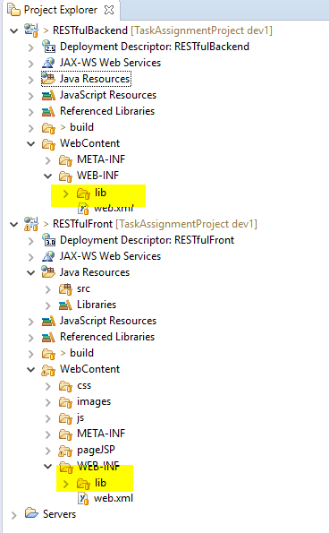

# 5. API RESTFul Description

1. Service back-end API for get Task Assign total in Database.

|  |  |
| --- | --- |
| Request URL | http://localhost:8080/RESTfulBackend/rest/TaskService/AllTask/ |
| Request Method | POST |
| Request | - |
| Response | C:\Users\KITTI\Desktop\1.jpg |
| Description | statusCode ‘0’ = Success  statusCode ‘1’ = Not Success, and will return statusMessage |

2. Service back-end API for create Task Assign.

|  |  |
| --- | --- |
| Request URL | http://localhost:8080/RESTfulBackend/rest/TaskService/CreateTask/ |
| Request Method | POST |
| Request |  |
| Response |  |
| Description | statusCode ‘0’ = Success  statusCode ‘1’ = Not Success, and will return statusMessage |

3. Service back-end API for update status [ Pending, Done ] Task Assign in Database.

|  |  |
| --- | --- |
| Request URL | http://localhost:8080/RESTfulBackend/rest/TaskService/UpdateTaskStatus/ |
| Request Method | POST |
| Request |  |
| Response |  |
| Description | statusCode ‘0’ = Success  statusCode ‘1’ = Not Success, and will return statusMessage |

Service back-end API for update Task Assign in Database.

|  |  |
| --- | --- |
| Request URL | http://localhost:8080/RESTfulBackend/rest/TaskService/UpdateTask/ |
| Request Method | POST |
| Request |  |
| Response |  |
| Description | statusCode ‘0’ = Success  statusCode ‘1’ = Not Success, and will return statusMessage |

Service back-end API for delete Task Assign in Database.

|  |  |
| --- | --- |
| Request URL | http://localhost:8080/RESTfulBackend/rest/TaskService/DeleteTask/ |
| Request Method | POST |
| Request |  |
| Response |  |

Service back-end API for delete all Task Assign in Database.

|  |  |
| --- | --- |
| Request URL | http://localhost:8080/RESTfulBackend/rest/TaskService/DeleteAllTask/ |
| Request Method | GET |
| Request | Parameter taskId |
| Response |  |

Service back-end API for get Task Assign by task id in Database.

|  |  |
| --- | --- |
| Request URL | http://localhost:8080/RESTfulBackend/rest/TaskService/GetTaskByID |
| Request Method | GET |
| Request | Parameter taskId |
| Response |  |

User Interface Description

URL <http://localhost:8080/RESTfulFront/initialTask.action>

